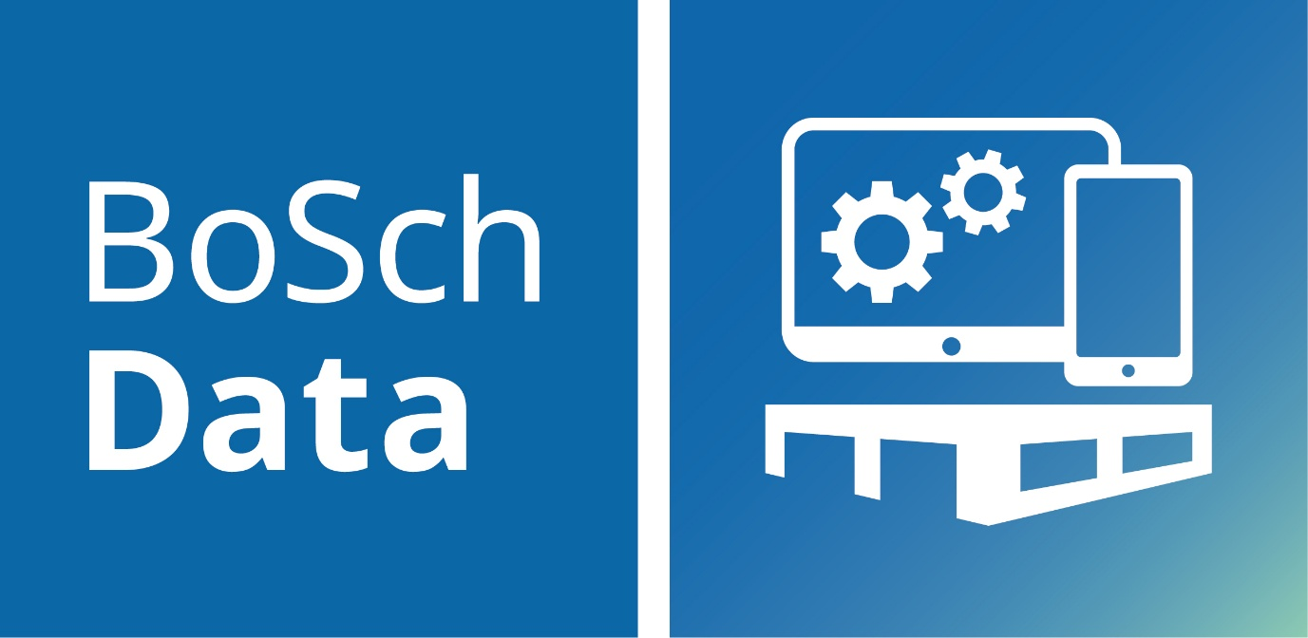

0




Factsheet
inspectorMAN

BoSch Data
BoSch Data GmbH is a certified Microsoft Dynamics partner, offering various solutions for Microsoft Dynamics Business Central. The applications range from individual modules/applications to large solution packages in the areas of soil, building materials and commodities/shipping. The development was focused on good usability for the users. New functions extend the scope of existing solutions or create new possibilities for the user.

BoSch Data – inspectorMAN App
The inspectorMAN is a fully integrated solution for Microsoft Dynamics 365 Business Central. Sanctions in case of delivery embargos protect your business and keep you up-to-date. With check data information keep you inform about actual sanctions during the order entry.

At the individual embago, you can assign
- special customer to an individual embargo list, or their ship-to address code
- special vendors to an individual embargo list, or their remit address code
- special countries to an individual embargo list
Add your embargo objects on the individual embargo list.
- add item and select variants (optional)
- select item category
- add ressource and sleect work type (optional)
- use custom tariff no. with wildcard for filtering areas of tariff no.
- create special keywords and add them as search parameters
- use regular expressions as search parameters for keywords/descriptions

